 PERI INSTITUTE OF TECHNOLOGY

IOT BASED WHETHER ADAPTIVE STREET LIGHTING SYSTEM

PRESENTED BY: MARIKALA.M

SANJAANA.S

SWETHA.B

SENTHURAMMAL.S

KIRUTHIKA.G

ANNA UNIVERSITY: CHENNAI 600 025

BONAFIDE CERTIFICATE

Certified that this project “IOT BASED ADAPTIVE STREET LIGHTING SYSTEM project” is the Bonafide of “MARIKALA.M(411520104058),

SANAJAANA.S (411520104083), SWETHA.B(411520104096),

SENTHURAMMAL.S(411520104086),KIRUTHIKA.G(411520104048).

SIGNATURE SIGNATURE

Mrs. K. VARALAKSHMI, M.E. Mrr.vijaya Narayanan

HEAD OF THE DEPARTMENT SUPERVISOR

Assistant Professor Assistant Professor

Dept of Computer Science & Engg. Dept of Computer Science & Engg. PERI Institute of technology Peri Institute of technology

Mannivakkam, Chennai 600 048 Mannivakkam, Chennai 600048

Submitted for the Viva-Voce examination held on ……………….

ABSTARCT

The IoT-based adaptive street lighting system project aims to enhance energy efficiency and optimize lighting conditions in urban areas. By integrating IoT technology, weather sensors, and intelligent algorithms, the system can dynamically adjust street lighting based on real-time weather conditions.

The project's main components include:

1. IoT Infrastructure: The system utilizes a network of interconnected devices, such as streetlights, weather sensors, and a central control hub. These devices communicate and exchange data through wireless connectivity.

2. Weather Sensors: Weather sensors are deployed throughout the city to collect real-time weather data, including information about ambient light, temperature, humidity, and precipitation. These sensors continuously monitor the environment and provide valuable inputs for the lighting control algorithm.

3. Lighting Control Algorithm: An intelligent algorithm analyzes the weather data received from the sensors and determines the optimal lighting levels for different weather conditions. It takes into account factors like natural light availability, visibility requirements, and energy efficiency goals. The algorithm dynamically adjusts the streetlight intensity and brightness accordingly.

4. Centralized Control Hub: A central control hub acts as the brain of the system, receiving data from weather sensors and coordinating communication with streetlights. It executes the lighting control algorithm and sends commands to individual streetlights to adjust their illumination levels.

5. Energy Management: The system incorporates energy management features to optimize power consumption. It can dim or switch off streetlights in areas with low or no activity, further reducing energy usage and carbon footprint.

TABLE OF CONTENT

|  |  |  |
| --- | --- | --- |
| S.NO | TITLE | PAGE NO |
| 01. | INTRODUCTION     * 1. Importance of efficient street lighting   2. Benefits of IoT in street lighting systems |  |
| 02. | PROBLEM STATEMENT  2.1 Inefficient Street lighting during different weather conditions    2.2 Energy wastage due to fixed lighting schedules  2.3 Lack of real-time monitoring and control |  |
| 03. | SOLUTION OVERVIEW    3.1 IoT-based weather-adaptive street lighting system |  |
|  | 3.2 Integration of sensors, actuators, and cloud platform    3.3 Real-time monitoring and control based on weather conditions |  |
| 04. | SYSTEM ARCHITECTURE  4.1 Sensor layer: Weather sensors (temperature, humidity, rainfall)    4.2 Communication layer: IoT gateway for data transmission  4.3 Cloud platform: Data processing and analysis    4.4 Actuator layer: Street lights and control mechanism |  |
| 05. | WEATHER MONITORING  5.1 Placement of weather sensors across the city    5.2 Continuous monitoring of temperature, humidity, and rainfall    5.3 Sensor data collection and transmission to the cloud platform |  |
| 06. | CLOUD BASED PROCESSING AND ANALYSIS  6.1 Data storage and analysis on the cloud platform  6.2 Weather pattern recognition algorithms  6.3 Determining optimal lighting levels based on weather conditions |  |
| 07. | ADAPTIVE LIGHTING  7.1 Real-time adjustment of street lighting intensity  7.2 Dimming or brightening of lights based on weather conditions  7.3 Energy-saving and reduction of light pollution |  |

|  |  |  |
| --- | --- | --- |
| 08. | BENEFITS  8.1 Energy efficiency and reduced carbon footprint  8.2 Cost savings through optimized lighting schedules      8.3 Enhanced safety and security in different weather conditions |  |
| 09. | CHALLENGES AND  LIMITATIONS  9.1 Initial setup and installation costs  9.2 Maintenance and sensor calibration  9.3 Connectivity issues in remote areas |  |
| 10. | CONCLUSION  10.1 IoT-based weather-adaptive street lighting system as a smart solution  10.2 Potential for scalability and future enhancements |  |

INTRODUCTION

* The advent of the Internet of Things (IoT) has revolutionized various industries, and one area that has greatly benefited is street lighting systems. Traditional street lighting operates on fixed schedules and lacks adaptability to changing environmental conditions. However, with the integration of IoT technology, we can create an intelligent and weather-adaptive street lighting system.
* The IoT-based adaptive street lighting system leverages sensors, connectivity, and cloud computing to monitor real-time weather conditions and dynamically adjust the lighting levels accordingly. By incorporating weather sensors such as temperature, humidity, and rainfall detectors, the system can optimize the street lighting to ensure energy efficiency, improved visibility, and increased safety.
* This innovative solution not only reduces energy wastage but also enhances the overall functionality of street lighting systems. With the ability to automatically adapt to different weather conditions, the IoT-based adaptive street lighting system provides a more sustainable and cost-effective approach to urban lighting.
* In the following presentation, we will explore the architecture, components, benefits, and challenges associated with this IoT-based adaptive street lighting system. By the end, you will have a comprehensive understanding of how this technology can transform traditional street lighting into a smart and efficient infrastructure, ultimately contributing to a more sustainable and intelligent urban environment.
  + Benefits of the IoT-based adaptive street lighting system project include:
* Energy Efficiency: By adjusting lighting levels based on weather conditions and real-time demand, the system reduces energy consumption and lowers electricity costs.
* Enhanced Safety: The adaptive lighting system improves visibility on roads, sidewalks, and public spaces, increasing safety for pedestrians and drivers, especially during adverse weather conditions.
* Environmental Impact: The optimized lighting control reduces carbon emissions and promotes sustainability by minimizing energy wastage.
* Cost Savings: The energy-efficient operation and reduced maintenance needs of the system result in cost savings for municipalities or organizations responsible for street lighting.
* Scalability and Flexibility: The modular design of the system allows for easy expansion and integration with other smart city initiatives or IoT-based infrastructure projects.
* Overall, the IoT-based adaptive street lighting system enhances urban lighting efficiency, reduces energy consumption, and improves safety and comfort for citizens.
* 1,2 Importance of Efficient Street Lighting in IoT-Based Street Lighting Systems:
* Efficient street lighting plays a crucial role in urban environments, contributing to various aspects of public safety, sustainability, and cost-effectiveness. In the context of IoT-based street lighting systems, the importance of efficiency is further amplified. Here are key reasons why efficient street lighting is essential in such projects:
* Energy Conservation: Traditional street lighting systems often operate on fixed schedules, resulting in unnecessary energy consumption during daylight or low-traffic hours. IoT-based adaptive street lighting systems can dynamically adjust lighting levels based on real-time conditions, optimizing energy usage and significantly reducing energy wastage.
* Cost Savings: By adopting energy-efficient lighting technologies and implementing adaptive controls, IoT-based street lighting systems can yield substantial cost savings in terms of reduced energy consumption and maintenance expenses. The ability to dim or brighten lights based on need ensures that resources are used efficiently, resulting in long-term financial benefits for cities and municipalities.
* Environmental Impact: Energy efficient street lighting contributes to the overall reduction of carbon emissions and environmental impact. By leveraging IoT technology to adjust lighting levels based on weather conditions, the system can minimize light pollution and provide the right amount of illumination where and when it is needed. This not only enhances the quality of life for residents but also preserves the natural environment and reduces the ecological footprint.
* Safety and Security: Well-lit streets enhance visibility and promote a sense of security for pedestrians, cyclists, and drivers. IoT-based adaptive street lighting systems can automatically respond to changing weather conditions, ensuring that the appropriate lighting levels are maintained. For instance, during foggy or rainy weather, the system can increase the brightness to enhance visibility, thereby reducing the risk of accidents and criminal activities.
* Flexibility and Scalability: The IoT-based approach offers scalability, allowing street lighting systems to adapt and expand as per the evolving needs of urban areas. With the ability to collect and analyze real-time data, these systems can provide valuable insights for urban planners and decision-makers, facilitating better resource management and infrastructure planning.
* In conclusion, efficient street lighting in IoT-based systems is of paramount importance due to its significant impact on energy conservation, cost savings, environmental sustainability, safety, and scalability. By embracing the potential of IoT technology, cities can transform their street lighting infrastructure into intelligent, adaptive, and efficient systems that cater to the needs of residents while promoting sustainability.
* 2.1 Energy Efficiency:
* IoT street lighting systems enable intelligent energy management by adjusting lighting levels based on real-time data and environmental conditions. By dynamically controlling the intensity of the lights, these systems optimize energy usage, resulting in significant energy savings and reduced carbon emissions.
* 2. Cost Savings: With the ability to monitor and control street lights remotely, IoT systems help reduce operational costs associated with manual maintenance and monitoring. Automated fault detection and predictive maintenance capabilities allow for efficient resource allocation and timely repairs, minimizing maintenance expenses.
* 3. Adaptive Lighting: IoT street lighting systems can adapt to changing needs and conditions. They can automatically adjust lighting levels based on factors such as traffic patterns, pedestrian presence, and weather conditions. This adaptive lighting ensures optimal illumination, enhances visibility, and improves safety for road users.
* 4. Real-time Monitoring and Control: IoT technology enables remote monitoring and control of street lights, providing real-time data on energy consumption, lighting status, and performance. This data can be analyzed to identify trends, patterns, and areas for optimization, allowing for proactive decision-making and efficient resource allocation.
* Improved Maintenance: IoT systems can proactively detect faults or failures in street lights, enabling timely maintenance and repair. This reduces downtime and improves the overall reliability of the street lighting infrastructure. Additionally, the ability to remotely control individual lights simplifies maintenance activities, reducing response times and minimizing disruption to traffic.
* Enhanced Safety and Security: IoT street lighting systems contribute to enhanced safety and security in urban areas. Intelligent lighting controls can adjust lighting levels based on specific events or situations, such as increased brightness in high-crime areas or during emergency situations. This improves visibility, deters criminal activities, and enhances the overall sense of security for residents and visitors.
* Data-driven Insights: IoT street lighting systems generate a wealth of data that can be leveraged for data-driven decision-making and urban planning. Analyzing the collected data helps identify usage patterns, optimize energy consumption, and plan future infrastructure development. This data-driven approach allows cities to make informed decisions, improve operational efficiency, and create more sustainable and livable urban environments.
* In summary, IoT street lighting systems offer a range of benefits including energy efficiency, cost savings, adaptive lighting, real-time monitoring and control, improved maintenance practices, enhanced safety and security, and valuable data-driven insights. These advantages make IoT-based street lighting systems a compelling choice for cities and municipalities looking to modernize their infrastructure and achieve more sustainable, efficient, and intelligent urban environments.
* 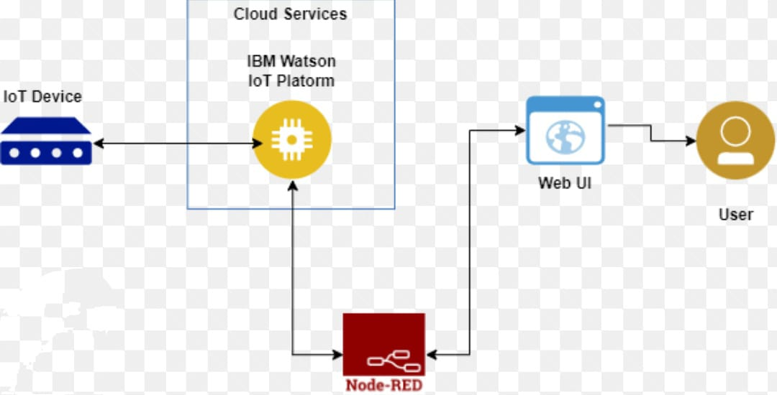
  + - PROBLEM STATEMENT
* Fixed lighting schedules in traditional street lighting systems result in energy wastage and inefficiency. The lack of adaptability to varying lighting requirements throughout the day leads to lights operating at full intensity even when there is sufficient natural light or low-traffic periods. This energy wastage not only increases operational costs but also contributes to unnecessary carbon emissions and environmental impact.
* Key issues related to energy wastage due to fixed lighting schedules include:
* 1.Unnecessary Lighting During Daylight Hours: Traditional street lighting systems continue to operate at full intensity even during daylight hours when natural light is abundant. This results in unnecessary energy consumption and wastage.
* 2. Low-Traffic Periods: Fixed lighting schedules do not account for fluctuations in traffic volume during different times of the day. Lights operate at the same brightness level regardless of low-traffic periods, leading to energy wastage during those times.
* 3. Inefficient Allocation of Resources: Fixed lighting schedules do not consider specific lighting needs in different areas or times. As a result, resources are allocated uniformly without considering the actual lighting requirements, leading to inefficient energy usage.
* 4. Lack of Real-time Adaptation: Traditional systems do not have the capability to adjust lighting levels in real-time based on changing conditions, such as sudden changes in weather or unexpected events. This inability to adapt to dynamic situations results in unnecessary energy consumption and inefficiency.
* Addressing the energy wastage due to fixed lighting schedules through an IoT-based street lighting system can significantly improve energy efficiency and reduce operational costs. By integrating sensors, connectivity, and intelligent controls, the system can dynamically adjust lighting levels based on real-time conditions, such as ambient light levels, traffic volume, and weather conditions. This adaptive approach ensures that energy is utilized optimally, minimizing wastage and promoting sustainability in urban lighting infrastructure.



Lighting control in cautious structures and homes can be robotized by having PC controlled lights and blinds close-by lighting up sensors that are appropriated in the building. Notwithstanding, programming a tremendous building light switches and apparently crippled settings can be unpropitious and extraordinary. We present a system that algorithmically sets up the control structure that can robotize any working without custom programming. This is cleaned by making the structure self-changing and self-learning. This paper depicted how the issue is NP hard regardless can be settled by heuristics. The consequent structure controls blinds to ensure despite lighting what's more adds counterfeit illumination to ensure light breaker remains engaging constantly of the day, adjusting for condition and seasons. Without daylight, the system resorts to fake lighting. Our methods fill in as nonexclusive control computations and are not prearranged for a particular spot. The likelihood, adaptively and adaptability features of the system have been grasped through various confirmed and imitated tests

3.1 Solution Overview: IoT-Based Adaptive Street Lighting

An IoT-based adaptive street lighting system is designed to address the limitations of traditional street lighting by leveraging IoT technology, sensors, and intelligent controls. The system aims to optimize energy usage, enhance safety, and improve overall efficiency by dynamically adjusting lighting levels based on real-time conditions. Here is an overview of the solution:

1. Integration of Sensors: The system incorporates various sensors, such as ambient light sensors, motion detectors, weather sensors (e.g., temperature, humidity, rainfall), and traffic sensors. These sensors provide real-time data about lighting requirements, weather conditions, traffic patterns, and pedestrian presence.

2. Connectivity and Communication: The sensor data is transmitted through an IoT gateway, establishing a communication link between the sensors and the central control system. Wireless or wired connectivity options ensure seamless data transmission and enable remote monitoring and control.

3. Cloud Platform: The collected sensor data is sent to a cloud-based platform for data processing, analysis, and storage. The cloud platform utilizes advanced algorithms and analytics to derive valuable insights, detect patterns, and optimize lighting schedules based on the data received.

4. Adaptive Lighting Control: The central control system, connected to the cloud platform, receives real-time data and instructions for adjusting lighting levels. Using intelligent controls, the system can dynamically dim, brighten, or switch off lights based on factors such as ambient light levels, traffic density, weather conditions, and pedestrian activity. This adaptive lighting control ensures optimal illumination while minimizing energy wastage.

5. Real-time Monitoring and Reporting: The IoT-based system allows for real-time monitoring of street lighting performance, energy consumption, and system health. It can proactively detect faults, failures, or malfunctions, triggering immediate alerts for maintenance and repairs. This real-time monitoring and reporting enable efficient resource allocation, reduce downtime, and improve maintenance practices.

6. Data-driven Insights and Optimization: The system generates a wealth of data that can be analyzed to gain insights into lighting usage patterns, energy consumption trends, and optimization opportunities. Data analytics and machine learning algorithms help identify areas for improvement, enabling cities to make informed decisions for resource optimization, infrastructure planning, and energy management.

The IoT-based adaptive street lighting system offers several benefits, including energy efficiency, cost savings, improved safety, reduced light pollution, and enhanced sustainability. By leveraging IoT technology and intelligent controls, cities can transform their street lighting infrastructure into a smart and adaptive system, ensuring optimal lighting conditions while minimizing energy wastage and contributing to a more sustainable urban environment.

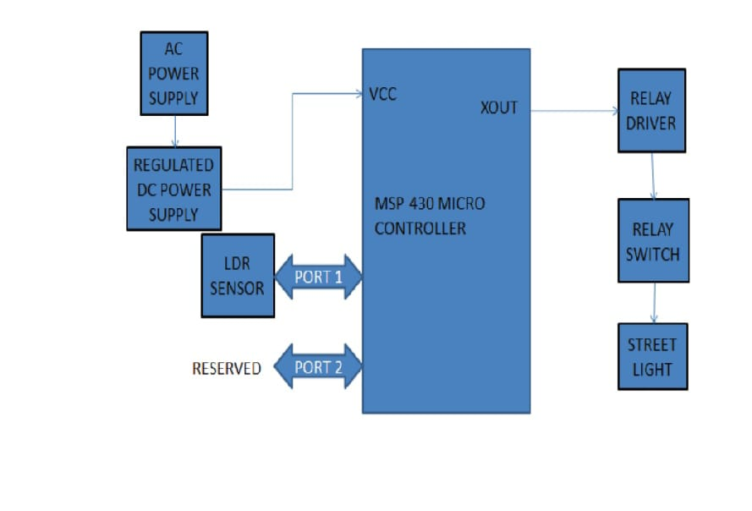

4.1 System Architecture of IoT-Based Street Lighting System:

The architecture of an IoT-based street lighting system involves the integration of various components and technologies to enable adaptive lighting control and real-time monitoring. Here is an overview of the system architecture:

1. Sensors: The system incorporates a range of sensors to collect real-time data about environmental conditions, traffic patterns, and lighting requirements. These sensors include ambient light sensors, motion detectors, weather sensors (temperature, humidity, rainfall), and traffic sensors. They capture data necessary for adaptive lighting control and decision-making.

2. IoT Gateway: The sensor data is transmitted to an IoT gateway, which acts as a communication interface between the sensors and the central control system. The IoT gateway ensures seamless data transfer and connectivity between the sensors and the cloud-based platform.

3. Cloud Platform: The sensor data is sent to a cloud-based platform for data processing, analysis, and storage. The cloud platform serves as the central hub for collecting, managing, and analyzing the sensor data. It utilizes cloud computing infrastructure and services to handle the data volume and perform real-time analytics.

4. Connectivity and Communication: The IoT gateway establishes connectivity with the cloud platform through wired or wireless communication protocols, such as Wi-Fi, cellular network, or LoRaWAN. This enables data transmission, remote monitoring, and control of the street lighting system.

5. Central Control System: The central control system receives data from the cloud platform and makes decisions for adaptive lighting control. It processes the real-time data and instructions to adjust lighting levels based on factors such as ambient light levels, traffic density, weather conditions, and pedestrian presence. The control system ensures efficient resource allocation and optimal lighting conditions.

6. User Interface: The system may include a user interface, which can be a web-based dashboard or a mobile application, allowing administrators to monitor and control the street lighting system. The user interface provides real-time insights, status updates, and control options for managing lighting schedules, energy usage, and maintenance activities.

7. Maintenance and Monitoring: The system incorporates mechanisms for proactive maintenance and monitoring. It can detect faults, failures, or malfunctions in the street lighting infrastructure and trigger immediate alerts for maintenance and repairs. Real-time monitoring helps optimize maintenance activities and reduce downtime.

8. Data Analytics and Insights: The collected data is processed and analyzed using data analytics techniques, including machine learning algorithms. This analysis generates valuable insights into lighting usage patterns, energy consumption trends, and optimization opportunities. Data-driven insights assist in making informed decisions for resource optimization, infrastructure planning, and energy management.

By integrating these components, an IoT-based street lighting system enables adaptive lighting control, real-time monitoring, proactive maintenance, and data-driven decision-making. This architecture ensures energy efficiency, cost savings, improved safety, and enhanced sustainability in urban lighting infrastructure.

4.2 Monitoring and Data Collection in IoT-Based Adaptive Street Lighting System:

An IoT-based adaptive street lighting system incorporates monitoring and data collection capabilities to gather real-time information about lighting conditions, energy consumption, system health, and environmental factors. Here's how monitoring and data collection are implemented in such a system:

1. Sensor Integration: The system integrates various sensors to collect data related to lighting requirements, traffic patterns, and environmental conditions. These sensors can include ambient light sensors, motion detectors, weather sensors (temperature, humidity, rainfall), and traffic sensors. They capture data at regular intervals or in response to specific events.

2. Data Transmission: The sensor data is transmitted to a central control system or an IoT gateway using wireless or wired communication protocols, such as Wi-Fi, cellular network, or LoRaWAN. The data is securely transmitted to ensure its integrity and confidentiality during transfer.

3. Real-time Monitoring: The central control system receives the sensor data and monitors the lighting infrastructure in real-time. It analyzes the data to gain insights into lighting levels, energy consumption, and system performance. Real-time monitoring allows for immediate detection of faults, failures, or anomalies in the street lighting system.

4. Cloud-Based Data Storage: The collected sensor data is typically sent to a cloud-based platform for storage and further analysis. Cloud storage provides scalability, durability, and accessibility to the data from anywhere. The cloud-based platform ensures that the data is securely stored and readily available for analysis and decision-making.

5. Data Analysis and Insights: The cloud-based platform performs data analytics on the collected sensor data to derive valuable insights. Data analysis techniques, including statistical analysis, machine learning, and predictive modeling, can be applied to identify patterns, trends, and anomalies. These insights help optimize lighting schedules, improve energy efficiency, and plan maintenance activities.

6. Reporting and Visualization: The system generates reports and visualizations based on the analyzed data to provide a clear overview of lighting performance, energy consumption, and system health. Reports can include metrics such as energy savings, maintenance alerts, and lighting efficiency. Visualization tools, such as dashboards and charts, make it easier for administrators to understand and interpret the data.

7. Maintenance and Alert System: The monitoring system includes mechanisms for proactive maintenance and fault detection. It can automatically generate alerts or notifications when abnormalities or failures are detected in the street lighting infrastructure. These alerts help ensure timely maintenance and reduce downtime.

By implementing robust monitoring and data collection mechanisms, an IoT-based adaptive street lighting system enables real-time insights, proactive maintenance, and data-driven decision-making. This facilitates efficient resource allocation, improved energy efficiency, enhanced safety, and optimal performance of the street lighting infrastructure.

Cloud-Based Data Processing and Analysis in IoT-Based Street Lighting System:

In an IoT-based street lighting system, cloud-based data processing and analysis play a crucial role in deriving valuable insights, optimizing operations, and enabling data-driven decision-making. Here's an overview of how cloud-based data processing and analysis are implemented in such a system:

1. Data Ingestion: The sensor data collected from the street lighting system's sensors is transmitted to the cloud platform for processing and analysis. This data includes information about lighting levels, environmental conditions, energy consumption, and system health.

2. Data Storage: The cloud platform provides storage capabilities to securely store the collected sensor data. Cloud storage ensures scalability, durability, and accessibility of the data. It allows for efficient data retrieval and retrieval of historical data for analysis.

3. Data Processing: The cloud platform processes the collected sensor data to extract meaningful information and perform various computations. This includes aggregating data, calculating energy consumption, identifying patterns, and performing statistical analysis.

4. Real-time Analytics: Real-time analytics techniques are applied to the sensor data to gain insights into the street lighting system's performance. This involves analyzing the data as it arrives to detect anomalies, identify trends, and monitor key performance indicators (KPIs) in real-time. Real-time analytics helps in immediate decision-making and timely response to changing conditions.

5. Batch Analytics: Batch analytics refers to processing large volumes of collected sensor data in batches or at scheduled intervals. This enables deeper analysis, trend identification, and long-term performance evaluation of the street lighting system. Batch analytics can be used to identify energy usage patterns, optimize lighting schedules, and detect maintenance requirements.

6. Machine Learning and AI: The cloud platform can leverage machine learning and artificial intelligence (AI) algorithms to analyze the sensor data. Machine learning models can be trained to predict energy consumption, optimize lighting levels, and identify anomalies or potential failures in the system. AI algorithms can help automate decision-making processes and provide intelligent recommendations.

7. Visualization and Reporting: The cloud platform provides tools for visualizing the analyzed data and generating reports. Dashboards, charts, and graphs can present real-time and historical data in a user-friendly manner, making it easier for administrators to understand the system's performance, energy usage, and maintenance requirements. Reports can include insights, KPIs, and recommendations for optimizing the street lighting system.

8. Integration with External Systems: The cloud-based platform can integrate with external systems, such as geographic information systems (GIS), weather data providers, and maintenance management systems. This integration enhances the analysis by incorporating additional context and data sources for improved decision-making.

By leveraging cloud-based data processing and analysis, an IoT-based street lighting system can gain actionable insights, optimize operations, and improve energy efficiency. The cloud platform enables scalability, flexibility, and accessibility to the sensor data, empowering cities to make informed decision .

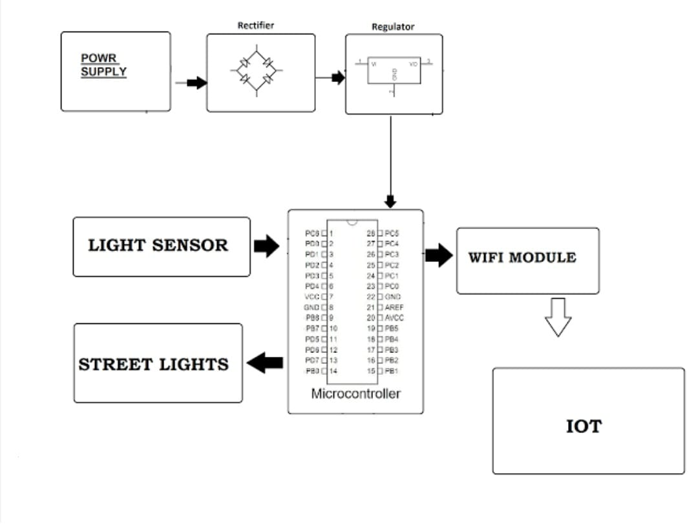

Adaptive Lighting Control in IoT-Based Adaptive Street Lighting System:

Adaptive lighting control is a key feature of an IoT-based adaptive street lighting system. It allows for dynamic adjustment of lighting levels based on real-time conditions, optimizing energy usage and ensuring appropriate illumination. Here's how adaptive lighting control is implemented in such a system:

1. Sensor Integration: The system incorporates various sensors, such as ambient light sensors, motion detectors, and traffic sensors. These sensors provide real-time data about lighting requirements, traffic density, pedestrian presence, and environmental conditions.

2. Data Collection and Processing: The sensor data is collected and processed in real-time or near real-time. The data includes information about ambient light levels, traffic patterns, and other relevant factors that influence lighting requirements.

3. Intelligent Controls: The central control system receives the sensor data and employs intelligent controls to adjust lighting levels accordingly. The control system utilizes algorithms and decision-making logic to determine the optimal lighting levels based on the real-time data inputs.

4. Dynamic Dimming and Brightening: Based on the sensor data, the control system can dynamically dim or brighten the street lights to match the lighting requirements. For instance, during low-traffic periods or when sufficient natural light is available, the system can dim the lights to conserve energy. Conversely, during high-traffic periods or in areas with low ambient light, the system can brighten the lights for enhanced visibility and safety.

5. Zone-based Control: The system can divide the street lighting infrastructure into different zones or areas based on factors such as traffic density, environmental conditions, or lighting requirements. This allows for granular control and adjustment of lighting levels specific to each zone. Different zones may have different lighting schedules or brightness settings based on their unique characteristics.

6. Adaptive Scheduling: The control system can dynamically adjust lighting schedules based on changing conditions. For example, during daylight hours, the system can reduce the lighting intensity or even turn off lights in areas with sufficient natural light. During inclement weather, such as heavy fog or rain, the system can increase the lighting levels for improved visibility.

7. Manual Override and Remote Control: The adaptive lighting control system can provide manual override capabilities, allowing authorized personnel to manually adjust lighting levels or temporarily override the automated control based on specific requirements or events. Remote control options, such as a web-based dashboard or mobile application, enable administrators to monitor and control the system from any location.

8. Energy Optimization: The adaptive lighting control system aims to optimize energy usage by dynamically adjusting lighting levels. By minimizing unnecessary energy consumption during low-traffic or daylight hours and ensuring appropriate illumination during high-traffic or low-ambient light situations, the system contributes to energy efficiency and cost savings.

Adaptive lighting control in an IoT-based adaptive street lighting system ensures that lighting levels are dynamically adjusted to meet specific requirements, optimize energy usage, enhance safety, and create a more sustainable and efficient lighting infrastructure.

Challenges and Limitations of IoT-Based Adaptive Street Lighting System:

While an IoT-based adaptive street lighting system offers numerous benefits, there are also challenges and limitations that need to be considered. Here are some of them:

1. Initial Deployment and Infrastructure: Implementing an IoT-based street lighting system requires significant upfront investment in infrastructure, including sensors, communication networks, and central control systems. The deployment process may involve retrofitting existing infrastructure or installing new equipment, which can be complex and time-consuming.

2. Connectivity and Reliability: Reliable and consistent connectivity is essential for the functioning of the IoT-based system. Any disruptions in the connectivity can hinder the real-time data transmission and control capabilities. Ensuring strong network coverage and addressing potential connectivity issues are crucial for the system's reliability.

3. Sensor Accuracy and Maintenance: The accuracy and reliability of the sensors used in the system play a critical role in capturing and providing accurate data. Regular maintenance and calibration of the sensors are necessary to ensure their optimal performance. Sensor failures or inaccuracies can lead to incorrect lighting adjustments or inadequate data for decision-making.

4. Data Security and Privacy: Collecting and transmitting data from the street lighting system to the cloud platform raises concerns about data security and privacy. The system must incorporate robust security measures to protect the collected data from unauthorized access, manipulation, or breaches. Compliance with data privacy regulations is also essential.

5. Power Supply and Backup: The IoT-based system relies on a continuous power supply to operate effectively. Power outages or failures can disrupt the system's functionality and impact lighting control. Implementing reliable power backup systems or incorporating energy harvesting techniques can help mitigate this limitation.

6. Scalability and Interoperability: As the street lighting system expands or integrates with other smart city applications, scalability and interoperability become important considerations. Ensuring that the system can handle increasing data volumes, support interoperability with other systems, and adapt to evolving technology standards is crucial for its long-term viability.

7. Data Processing and Analysis Complexity: Processing and analyzing the large volumes of data collected by the system can be complex. It requires robust data processing and analytics capabilities, as well as skilled resources to derive meaningful insights and make data-driven decisions. Efficient data management and processing techniques, such as edge computing, can help overcome these challenges.

8. Public Acceptance and User Behavior: Introducing new technologies and changes to street lighting may face resistance or require user education. Public acceptance, understanding, and cooperation are necessary for the successful implementation and adoption of the IoT-based adaptive street lighting system.

While these challenges and limitations exist, they can be addressed through careful planning, robust infrastructure, ongoing maintenance, stakeholder engagement, and continuous improvement efforts. By addressing these challenges, the system can maximize its benefits and contribute to a more efficient, sustainable, and safer urban environment.

Implementing an IoT-based adaptive street lighting system requires a combination of hardware and software components. Here's a high-level program outline to give you an idea of the steps involved:

1. Hardware Setup:

a. Install and mount the required sensors, such as ambient light sensors, motion detectors, and traffic sensors, at suitable locations.

b. Connect the sensors to a microcontroller or IoT gateway that will collect and transmit the sensor data.

2. Connectivity:

a. Establish a reliable and secure network connectivity option, such as Wi-Fi, cellular network, or LoRaWAN, to enable data transmission from the sensors to the central control system.

3. Cloud Platform Setup:

a. Set up a cloud-based platform or utilize an existing IoT platform that provides data storage, processing, and analytics capabilities.

b. Configure the cloud platform to receive and store the sensor data securely.

4. Data Ingestion and Processing:

a. Develop or use appropriate protocols and APIs to transmit the sensor data from the microcontroller or IoT gateway to the cloud platform.

b. Implement data ingestion mechanisms to receive and process the sensor data in real-time or near real-time.

c. Validate and preprocess the collected data to remove noise and ensure data accuracy.

5. Adaptive Lighting Control:

a. Develop intelligent algorithms and decision-making logic to analyze the sensor data and determine optimal lighting levels.

b. Implement dynamic dimming and brightening capabilities to adjust the lighting levels based on real-time conditions.

c. Incorporate zone-based control and adaptive scheduling to tailor lighting settings for specific areas or time periods.

6. User Interface and Control:

a. Create a user interface, such as a web-based dashboard or mobile application, to allow administrators to monitor and control the street lighting system.

b. Implement functionalities for remote control of lighting levels, manual overrides, and scheduling adjustments through the user interface.

7. Data Analytics and Insights:

a. Utilize data analytics techniques, including machine learning algorithms, to gain insights from the collected sensor data.

b. Develop analytics models to predict energy consumption, identify usage patterns, and optimize lighting schedules.

c. Generate visualizations and reports to present the analyzed data and insights in a user-friendly manner.

8. Testing and Deployment:

a. Perform thorough testing to ensure the system functions as intended and meets the required performance criteria.

b. Deploy the IoT-based adaptive street lighting system in the desired urban area, considering factors such as coverage, scalability, and interoperability with other systems.

9. Maintenance and Updates:

a. Establish a maintenance plan to regularly monitor and calibrate the sensors, update software components, and address any system issues or failures.

b. Continuously evaluate and improve the system based on user feedback, performance metrics, and technological advancements.

Note that the actual implementation details and programming languages/frameworks used may vary based on the specific hardware and software choices, as well as your programming preferences and expertise. It's important to consider the integration of different components, security measures, and scalability aspects while implementing the program for an IoT-based adaptive street lighting system

SOURCE CODE:

Setting up MQTT Communication:

Install the necessary MQTT library. For example, you can use the Paho MQTT library for Python by running pip install paho-mqtt.

Import the required MQTT modules in your Python script:

import paho.mqtt.client as mqtt

def on_connect(client, userdata, flags, rc):

print("Connected to MQTT broker")

client.subscribe("sensor/topic") # Subscribe to the topic where sensor data is published

def on_message(client, userdata, msg):

print("Received message: " + str(msg.payload))

# Process the received sensor data and make decisions for lighting control

# Implement your logic here

client = mqtt.Client()

client.on_connect = on_connect

client.on_message = on_message

broker_address = "mqtt broker address"

broker_port = 1883 # Default MQTT port

client.connect(broker_address, broker_port, 60)

# Start the MQTT network loop

client.loop_start()

def control_street_lights(brightness):

# Implement code to control the street lights based on the desired brightness

# Send commands to adjust the brightness or turn lights on/off

# Use the appropriate communication protocol or APIs for your specific hardware

# Example code:

if brightness > 0.5:

# Turn on the street lights or increase their brightness

pass

else:

# Dim the street lights or turn them off

pass

# Inside the on_message function, after processing the sensor data:

control_street_lights(desired_brightness)

CONCLUSION::

In conclusion, an IoT-based adaptive street lighting system offers significant benefits and advancements in the field of urban lighting. By leveraging sensors, connectivity, and intelligent controls, this system provides dynamic lighting adjustments based on real-time conditions, leading to improved energy efficiency, enhanced safety, and optimized illumination. The ability to monitor, collect, and analyze data enables data-driven decision-making, allowing for better resource allocation, maintenance planning, and operational optimizations.

With adaptive lighting control, the system can respond to changes in traffic patterns, environmental conditions, and lighting requirements, ensuring that the right amount of light is provided at the right time and place. This adaptive approach minimizes energy wastage, reduces light pollution, and contributes to environmental sustainability. Furthermore, the integration of IoT technologies allows for remote monitoring and control, enabling efficient management and maintenance of the street lighting infrastructure.

While challenges and limitations exist, such as infrastructure requirements, connectivity issues, and data security concerns, these can be overcome through careful planning, proper implementation, and ongoing maintenance.

Overall, an IoT-based adaptive street lighting system holds great potential in creating smarter, more efficient, and sustainable urban environments. It offers improved visibility, energy savings, and increased safety for pedestrians and drivers alike. By embracing this innovative approach, cities can enhance their lighting infrastructure, reduce energy consumption, and create more livable and resilient communities.